Name: Date:
UNIT 6 Test Review
- The expression ${\left({4x}^{4}\right)}^{2}$can be simplified to

  - $4x^{6}$
  - $8x^{6}$

  - ${4x}^{8}$
  - $16x^{8}$

- Which of the following is the simplification to $\frac{{14x}^{4}y^{5}}{{7x}^{6}y^{3}}$?

  - $\frac{2y^{2}}{x^{2}}$

  - $2x^{2}y^{2}$

  - $\frac{1}{2x^{2}y^{2}}$

  - $2xy$

- The Construction Class has an assignment to draw a blueprint for a shed to hold their tools. The wall length is $12x^{2}$. The width of the wall is ${6x}^{3}$. What is the area of the garden? (Area = Length * Width)

A. ${18x}^{6}$ C. $72x^{5}$

B. $18x^{5}$ D. $72x^{6}$

- Which of the following is the equation of an increasing exponential function?

A. $y=\left(\frac{2}{3}\right)x^{2}$
B. $y={(2)}^{x}$

C. $y=8x+1$
D. $y={\left(\frac{1}{5}\right)}^{x}$

- The data estimated for the state of Tennessee for students enrolled in homeschool between 2017-2018 year is modeled by the function $f\left(x\right)=32,297{(1.03)}^{x}$. Is the student enrollment increasing or decreasing and by what percent?

  - Decreasing by 0.97% C. Increasing by .03%

B. Increasing by 1.03% D. Increasing by 3%
- Which of the following could be the equation of the exponential function shown below?
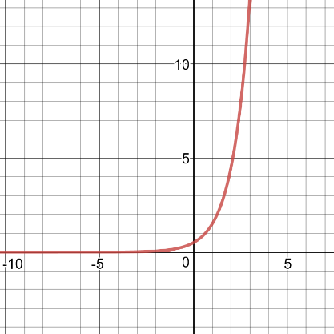

A. $y=2{\left(\frac{1}{3}\right)}^{x}$
B. $y=\frac{1}{2}{\left(3\right)}^{x}$
C. $y={\left(3\right)}^{x}$
D. $y={\left(\frac{1}{3}\right)}^{x}$

- The model for compound interest is $A={P(1+\frac{r}{n})}^{nt}$ where P = principal, n = number of times compounded per year, r = interest rate (decimal), and t = time (years). If you deposit $8,000 into an account paying 7% annual interest compounded quarterly, how much would you have after 8.25 years?

  - $14,181.62 C. $74,602.72

B. $50,419.39 D. $10,486.37

- An average freshman class of UT students is increasing at a rate of 9% per year. The freshman class of UT can be modeled by using an exponential function. If there were originally 5,180 students recorded to start in the fall, which of the following equations models the population the freshman class y-years after the fall class of 5,180 were recorded?

A. P = 5180(9) y
C.
P = .09y + 5180

B. P = 5180(.09)y
D.
P = .09(5180) y

- If the first three terms of a geometric sequence are 5 and -30 and 180, which of the following would be the 7th term? (The formula for a geometric sequence is $a_{n=}a_{1}r^{n-1}$)

A. 1080 C. 233280
B. -233280 D. -1080

- A radioactive material has a mass given by m (t ) = 320 (0.88)t, where the mass is in grams and the time, t, is in years. Which of the following gives the difference of the mass over the interval 3 ≤ t ≤ 7 years?
  - 130.78 g/ year B. -88 g/ year
C.218.07 g/ year D. -87.29 g/ year.

Constructive Response Questions
- An exponential function, f, is shown in the table below. Write an equation for it in f( x) = a(b)x form.
x | 0 | 1 | 2 | 3
f ( x) | 4 | 16 | 64 | 256

- A hive of bees has been decreasing by 24% per year. If a hive currently contains 60,000 bees, what will its population be 4 years from now? $y={a\left(1-r\right)}^{t}$

MUST SHOW WORK ON THE BACK OF YOUR ANSWER DOC!

- A function passes through the points (0, 2) and (2, 18).

- Write the equation of a linear function that passes through these two points. Linear, y = mx + b

- Write the equation of an exponential function that passes through these two points.
Exponential, y =a(b)x

- How much greater is the exponential function's value at x = 4 than the linear function's value? Show how you arrived at your answer.

- A local weather station claims that the number of tornados is increasing exponentially. In September, there were 5 tornados reported. In October, there were 15 and in November there were 25 cases reported. In December, there were 30 tornados. Was the weather station's claim of exponential increase accurate? Justify your response.

